Gurjus Singh

10/25/2020

MSDS 460 – Decision Analytics

MSDS 460 HW #3

1.

We can define the Decision Variables as X11…X14 for the cities to LA and X21…X24 from the cities to NY and Y1 and Y2 for Binary Variables Seattle and Baltimore.

X11, X21 – would be decision variables for Atlanta

X12, X22 – would be decision variables for Tulsa

X13, X23 – would be decision variables for Seattle

X14, X24 – would be decision variables for Baltimore

With this information our Optimization function is

MIN 8*X11 + 4*X12 + 5*X13 + 4*X14 + 5*X21 + 7*X22 + 6*X23 + 6*X24

Our constraints are

Y1 + Y2 = 1

X11 + X12 <= 600

X21 + X22 <= 900

X13 + X23 <= 500*Y1

X14 +X24 <= 500*Y2

X11 + X12 + X13 + X14 >= 800

X21 + X22 + X23 + X24 >= 1200

All our decision variables need to be integers and above 0.

X11..X24 >= 0; Y1,Y2 >= 0

With this information the problem is set up in excel like this:

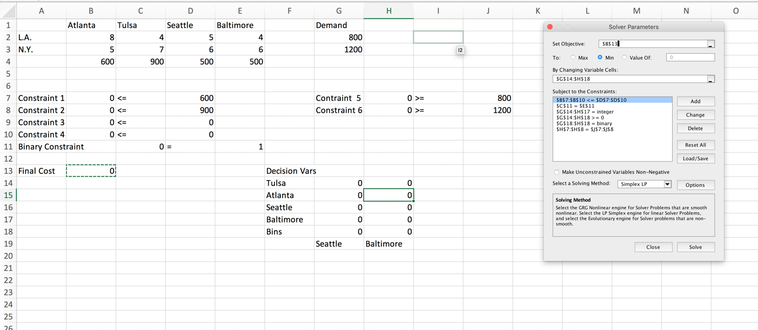

Here are the behind the cell formulas:

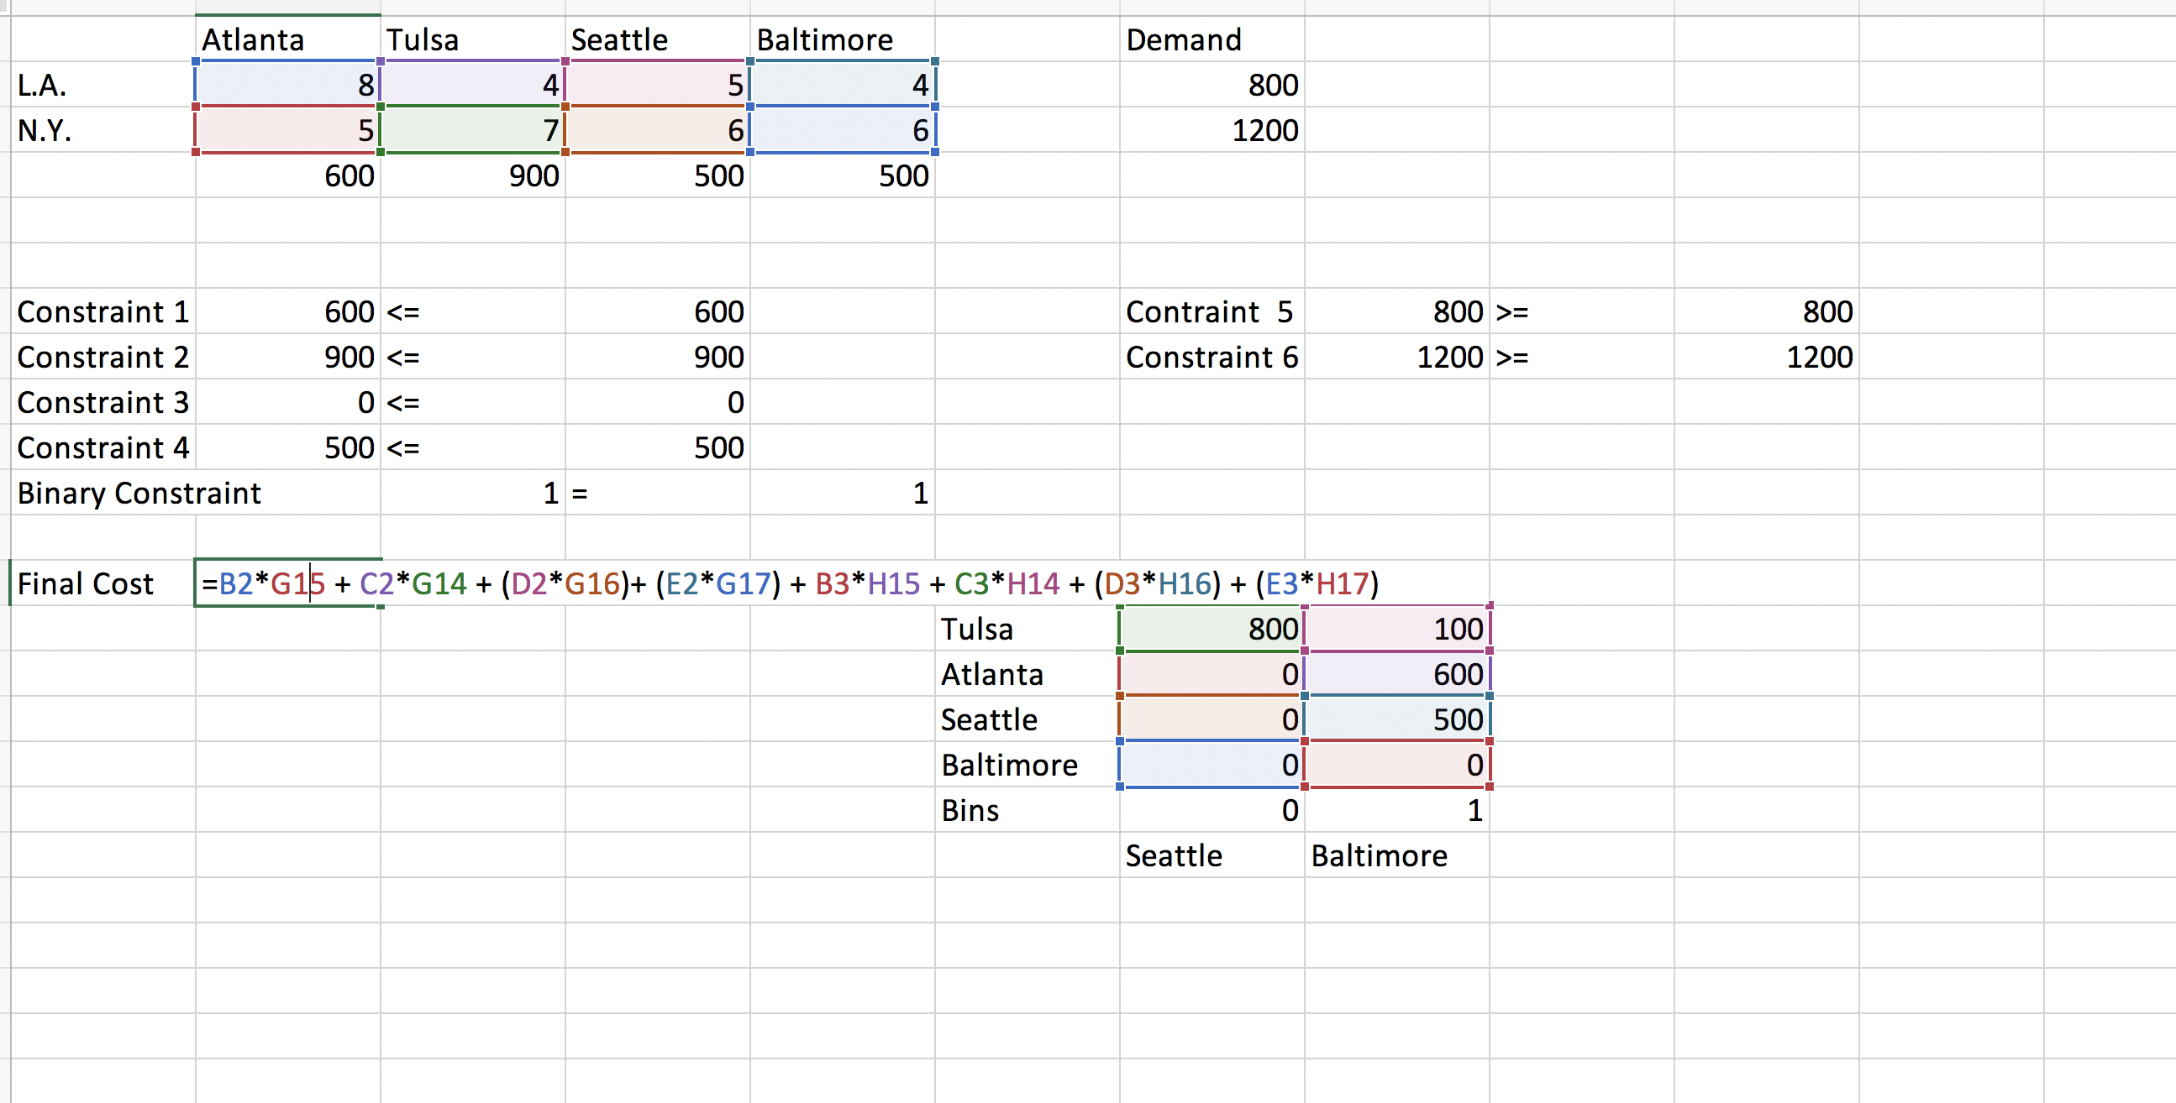

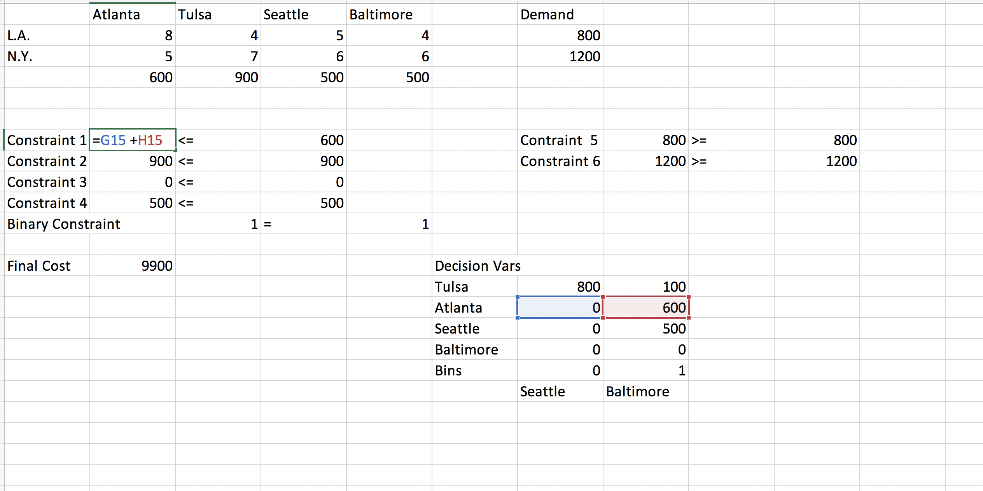

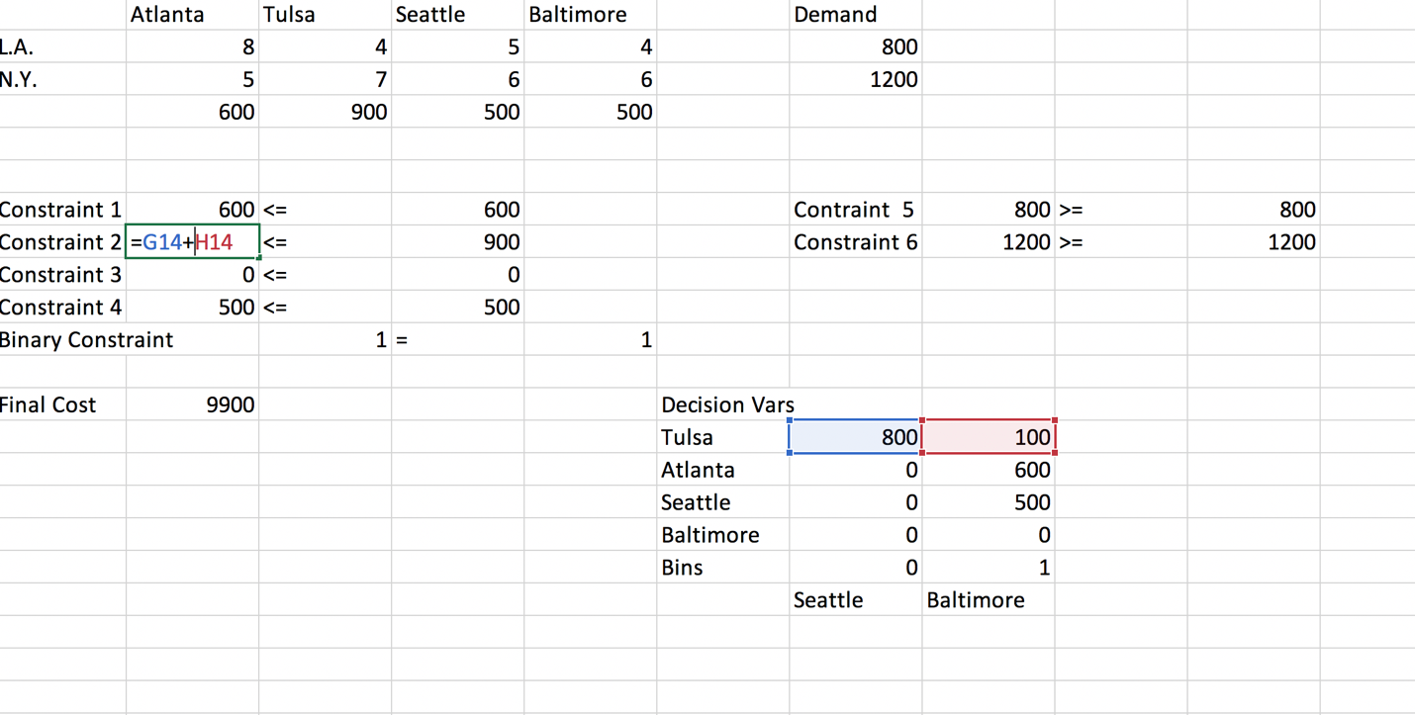

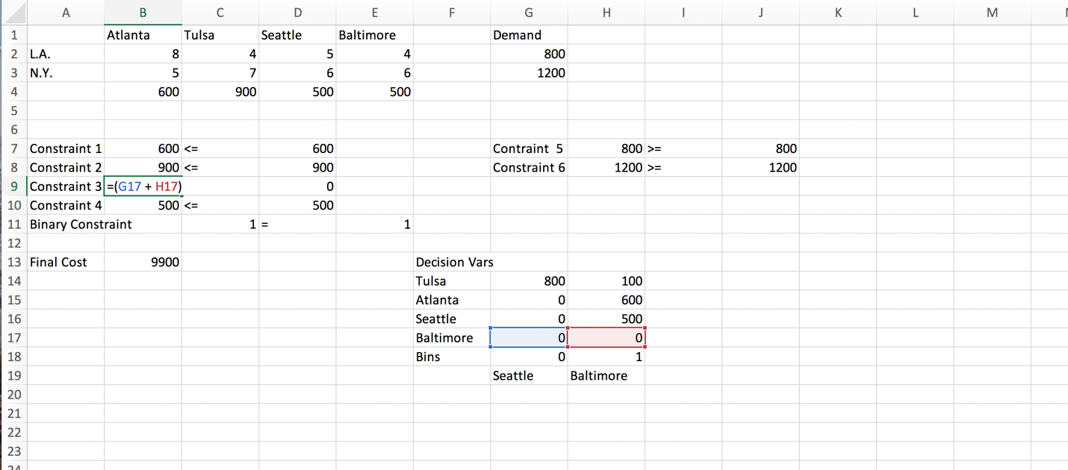

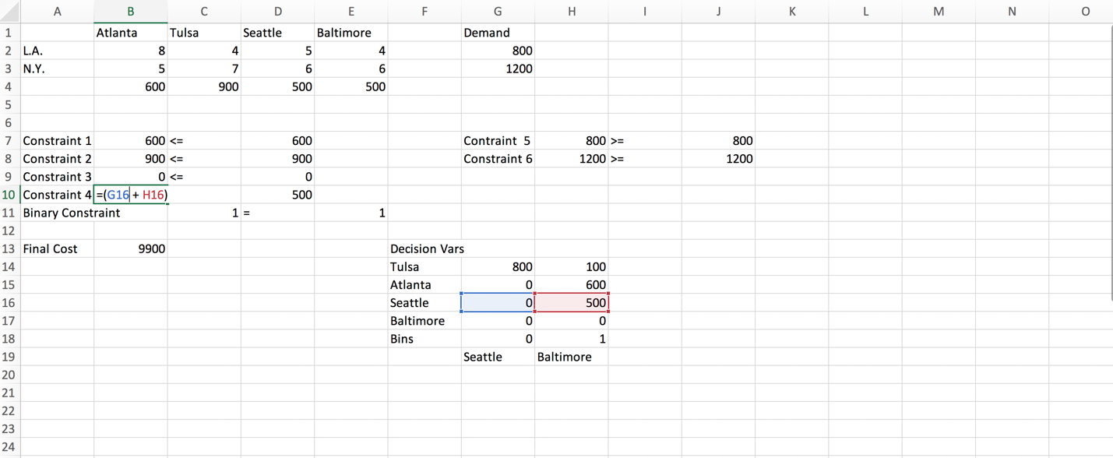

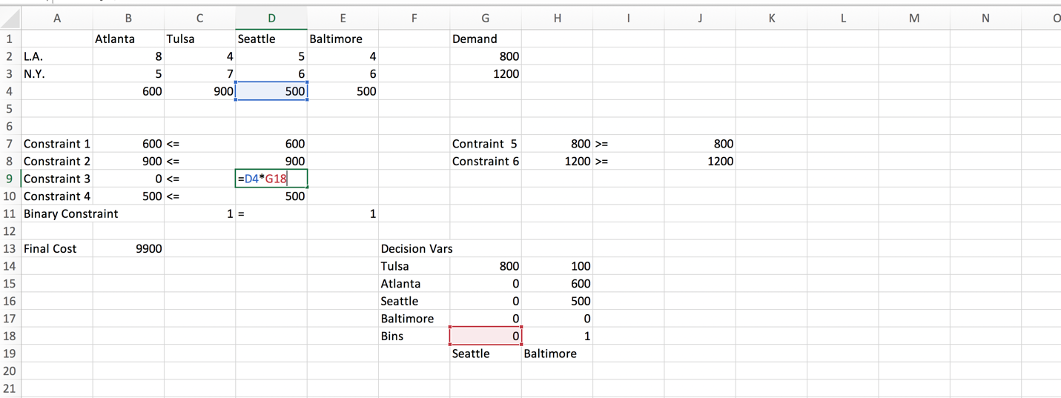

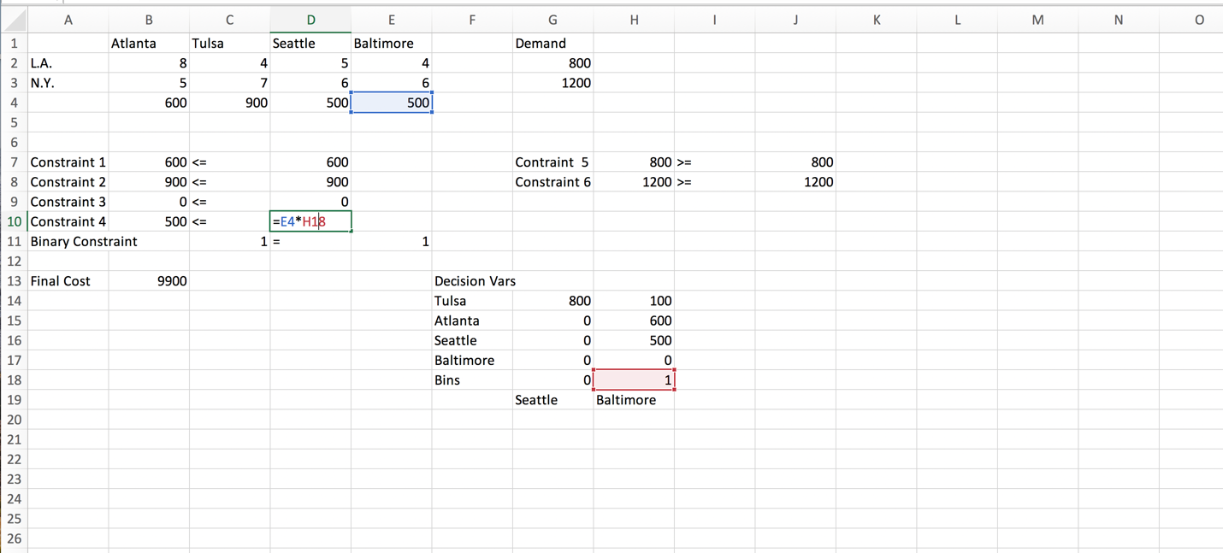

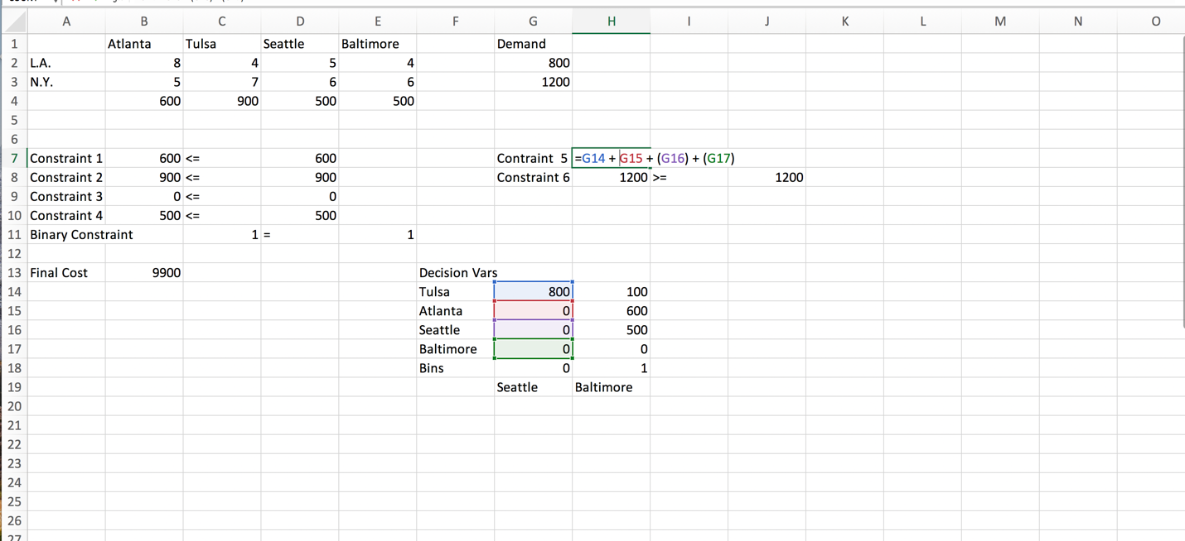

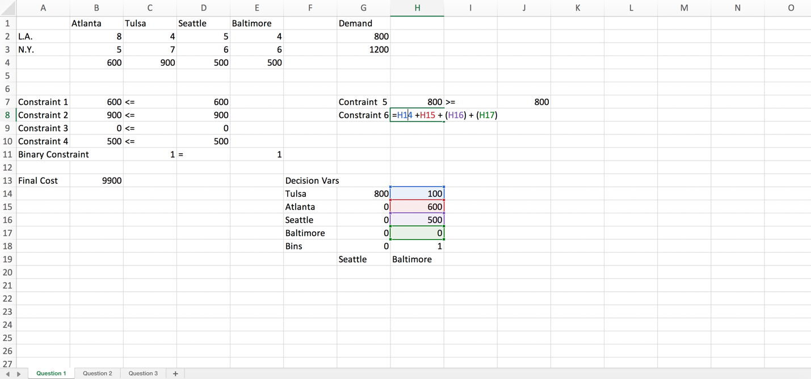

Our solution is then...

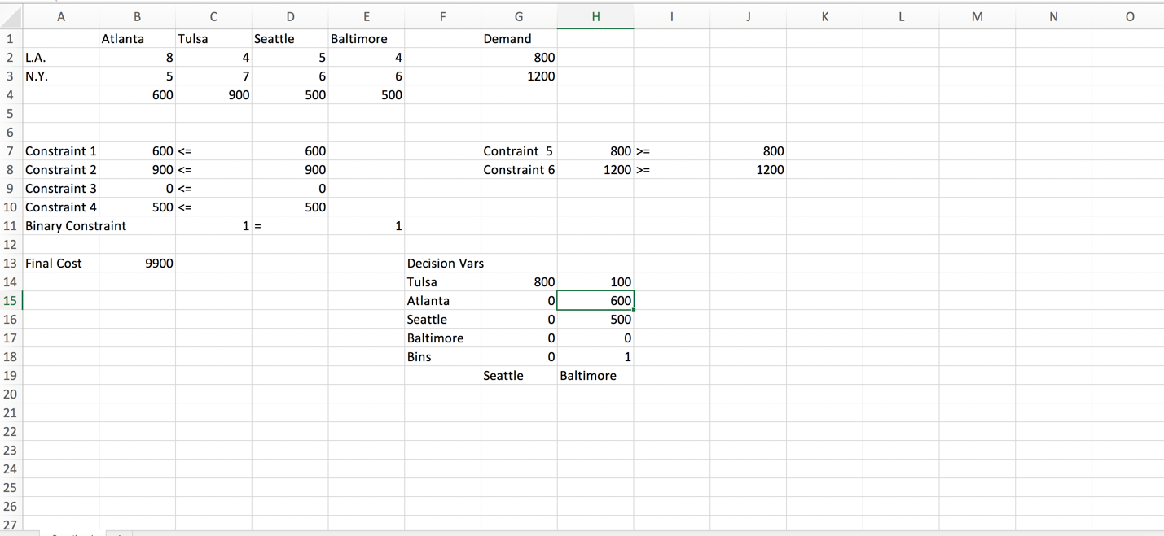

Optimal cost is 9,900; the Variables are X12 = 800, X22 = 100, X21 = 600, X23 = 500 and Y2 = 1. So we set up a new plant in Baltimore.

I have also set up the same problem in Gurobi shown below:

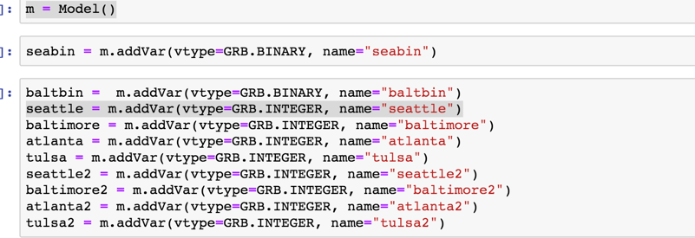

Variable are defined above ^

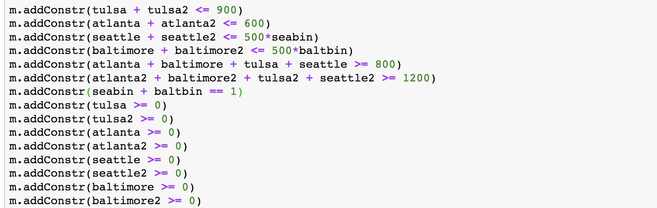

Constraints are defined above ^

Here is the objective function



Here is our optimal solution with variables and their values:

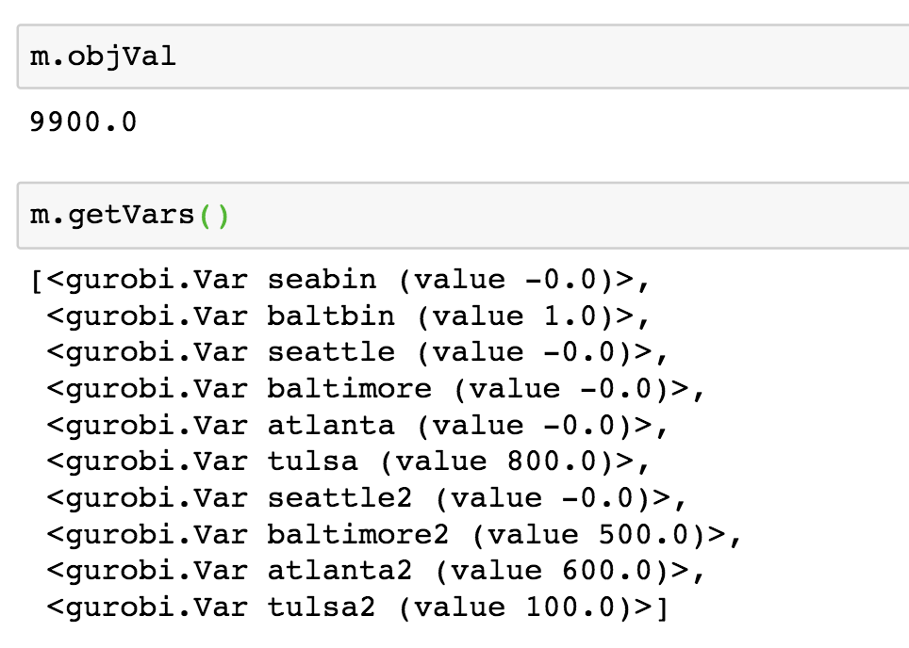

2. We can define our decision variables for each meat as X1…X4.

So X1 = Beef

X2 = Pork

X3 = Chicken

X4 = Turkey

From this our constraints are

X1 + X2 + X3 + X4 = 0.125 constraint for 2oz, I converted to pounds which is why I show 0.125

640*X1 + 1055*X2 + 740*X3 + 528*X4 <= 100 CAL – constraint for at most 100 calories

32.5*X1 + 54*X2 + 25.6*X3 + 6.4*X4 <= 6 grams of fat – constraint for nothing more than 6 grams of fat

210*X1 + 205*X2 + 220*X3 + 172*X4 <= 27 grams of cholesterol– constraint for nothing more than 27 grams of cholesterol

Optimization Function is

MIN 0.76*X1 + 0.82*X2 + 0.64*X3 + 0.58*X4

We need to make sure we satisfy nonnegativity so,

X1…X4 >= 0

Now we can set this up in Excel:

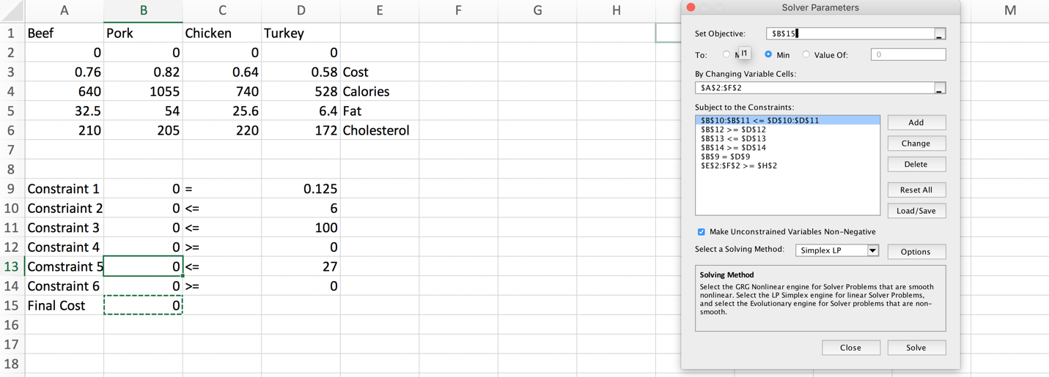

Here are the behind the cell formulas:

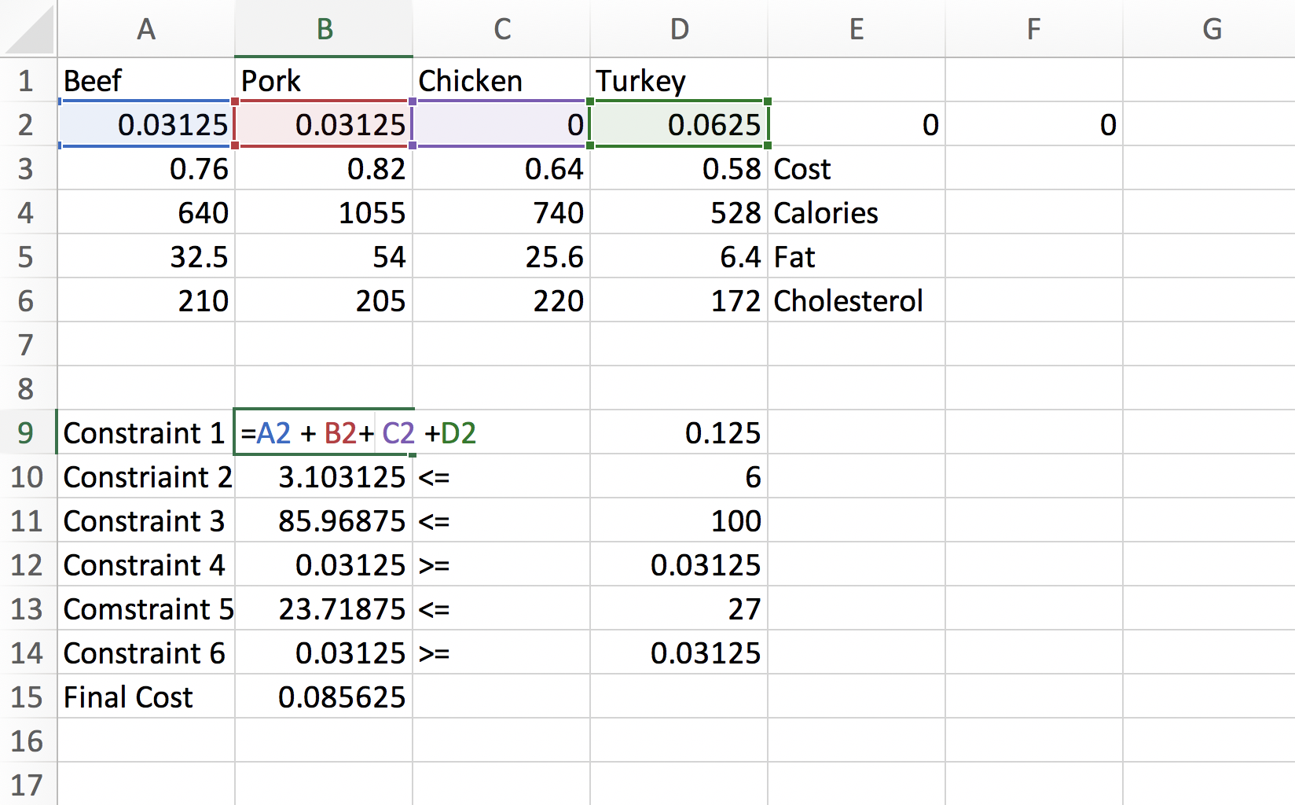

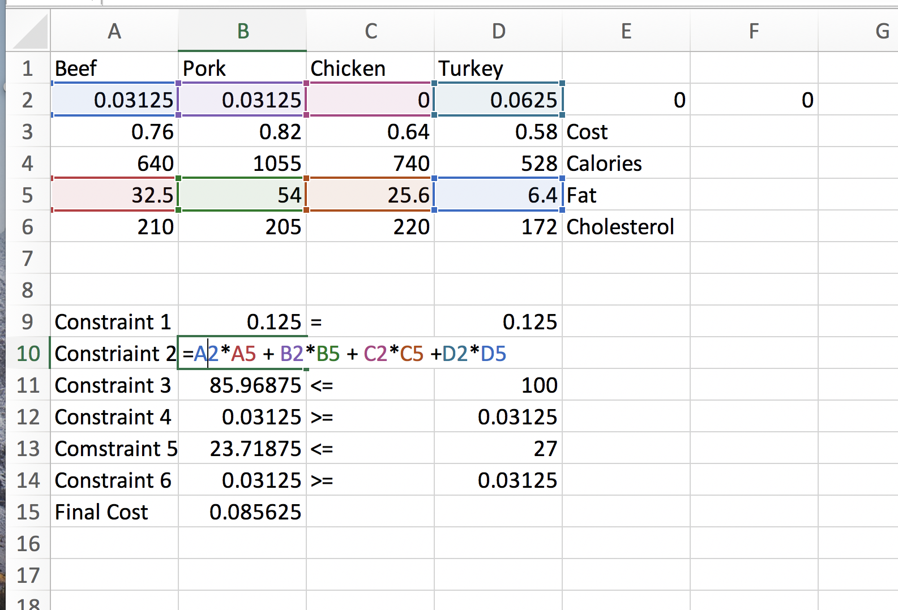

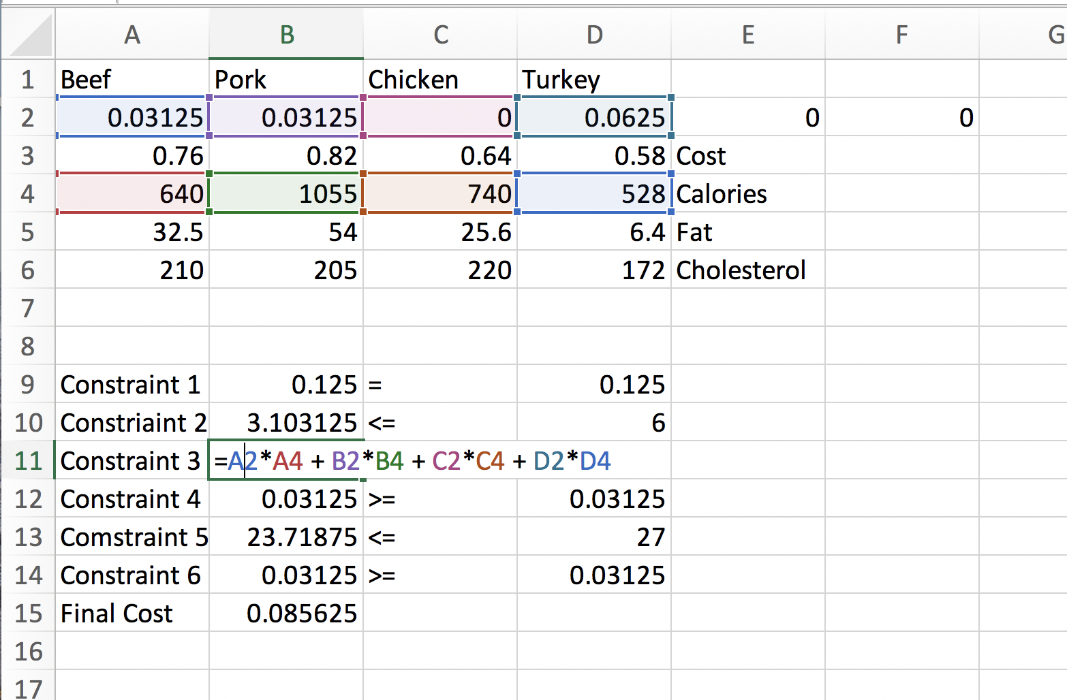

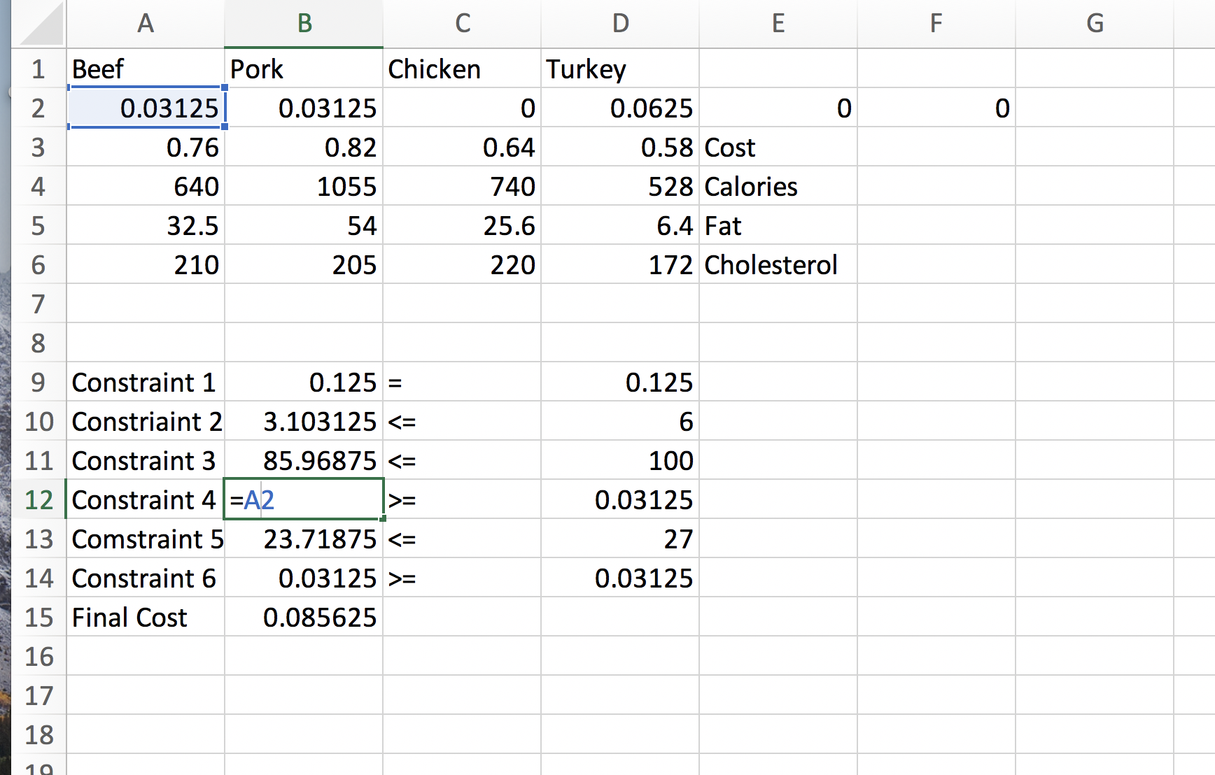

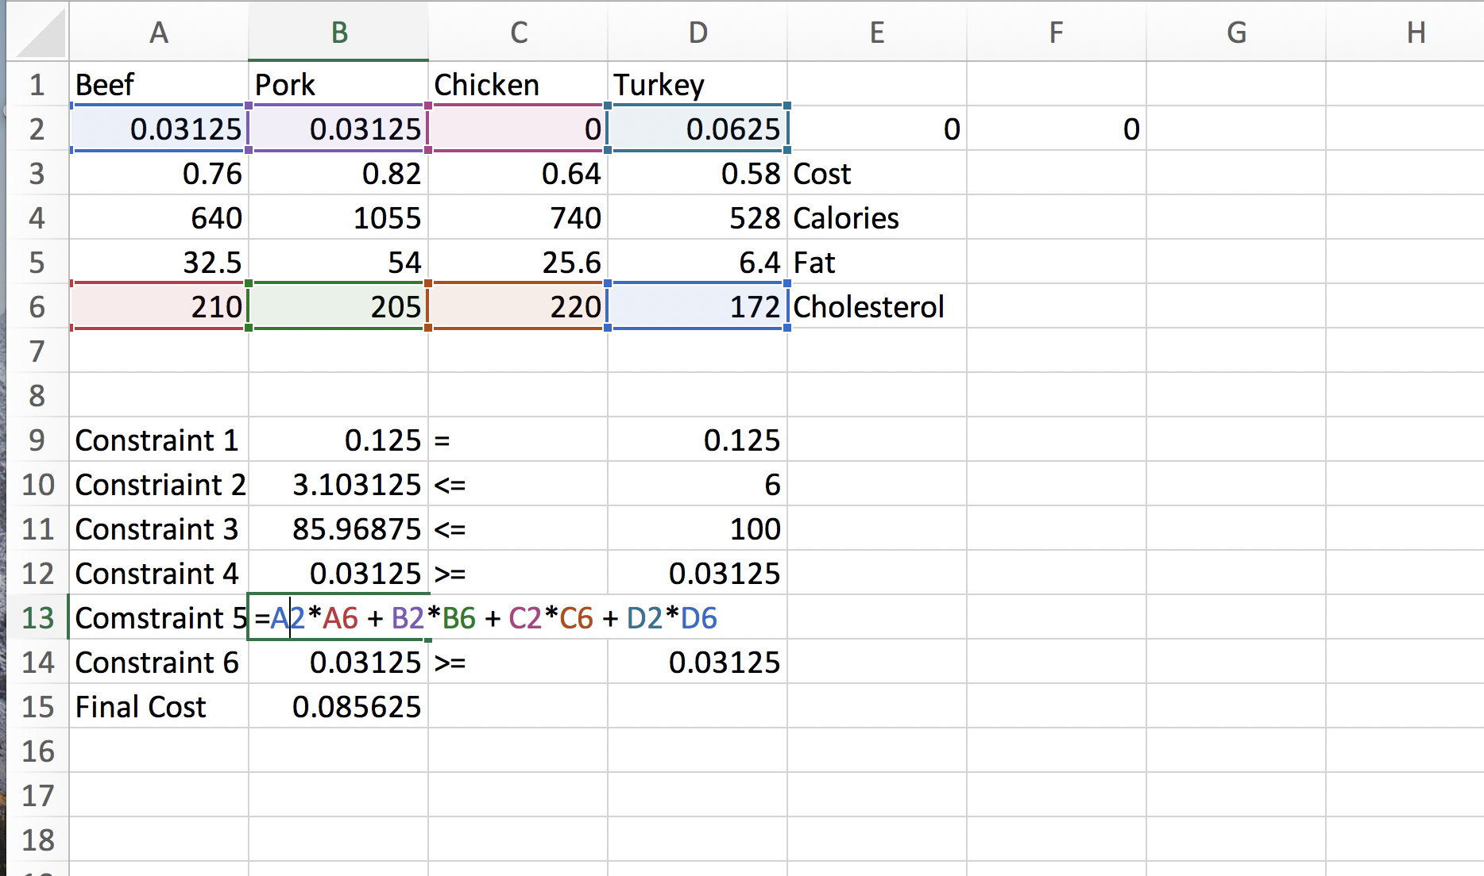

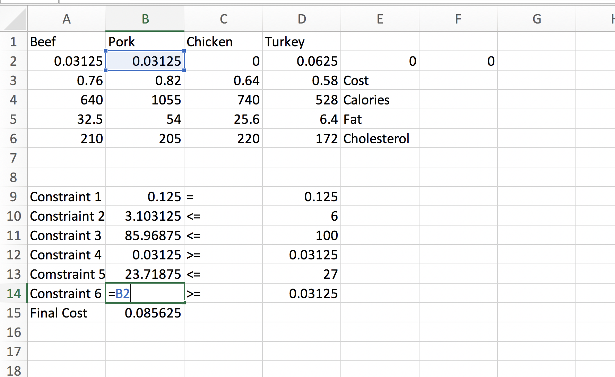

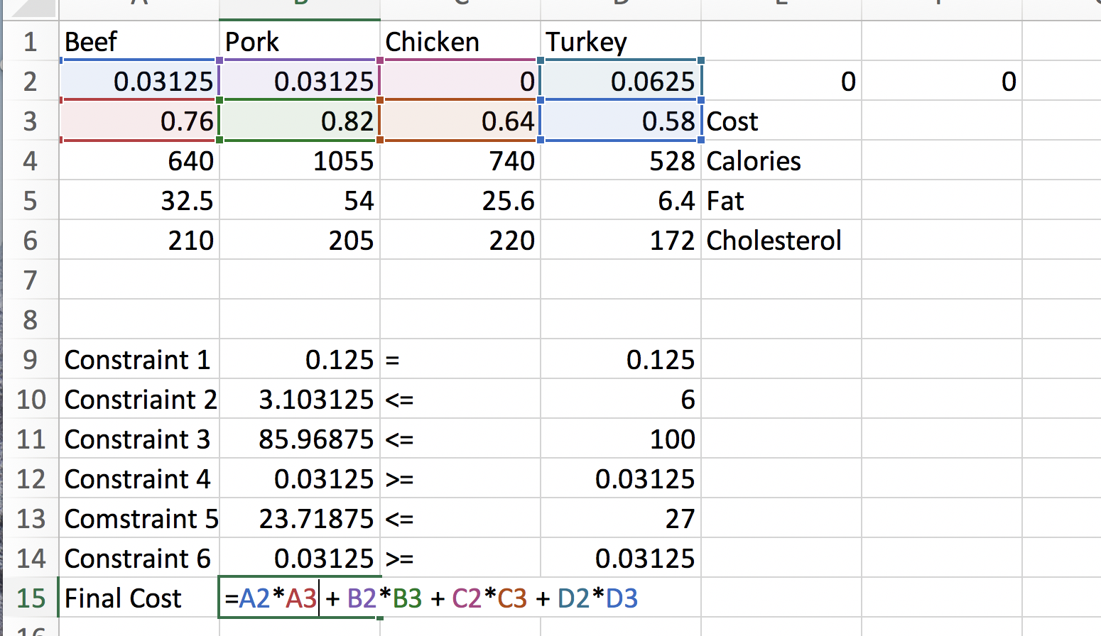

When we solve the problem, our optimal solution is 0.085625 and our decision values are X1 = 0.03125, X2 = 0.03125, X3 = 0, X4 = 0.0625 shown below:

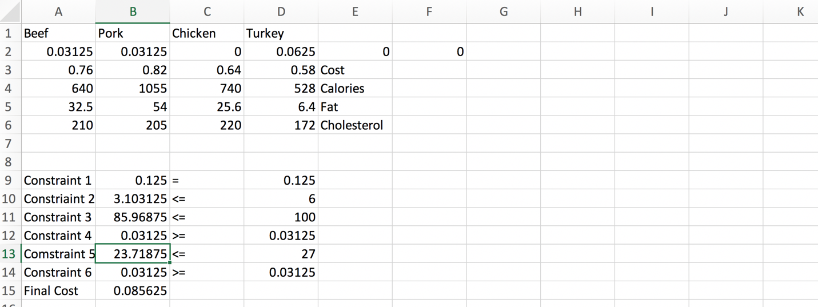

Now we can solve this in Gurobi, here is the setup and the answer:

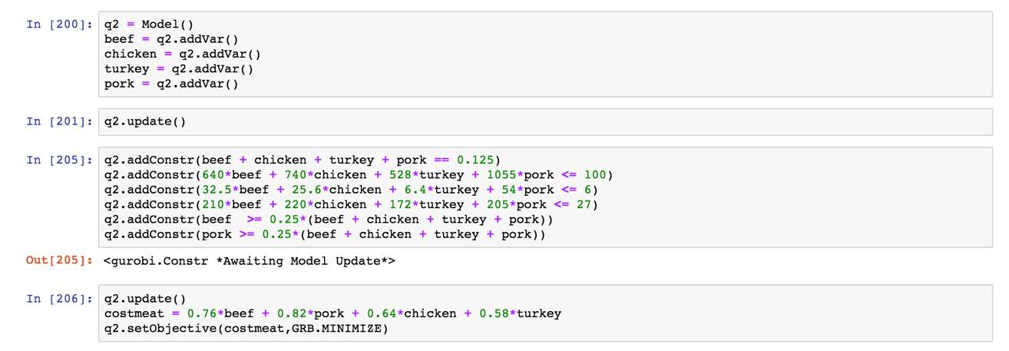

Decision variables, constraints, optimization function all defined above ^

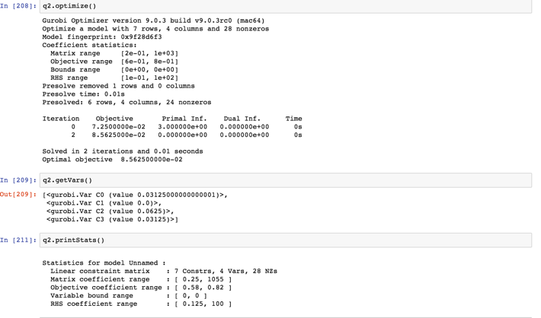

As you can see we get the same values that we get in Excel, but in scientific notation.

3.

**5 X 5 SOLUTION:**

For this problem, our goal is to minimize total set up time, by optimization. This is to eliminate mass casualties such as in war.

In order to perform this problem, one needs to duplicate the setup time matrix of 5x5 first. This is below in excel:

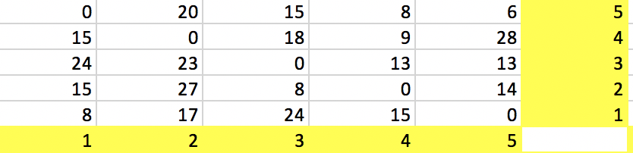

Then we create a binary decision variable matrix of the same size:

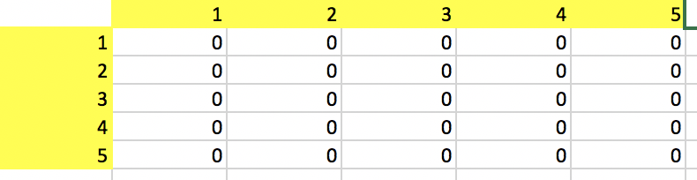

In order to find minimum cost, we take the two matrixes and multiply and add them which is called SUMPRODUCT() in Excel.

We also add constraints so that each row in our binary matrix is equal to 1, and each column is = 1. This is so we only get one selection for each column.

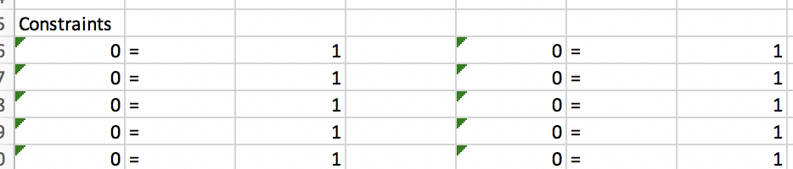

I noticed when I ran the solution the first time that I got a subroute at 1,5,1, so I made a new constraint which is cell 1,5 should be = 0. This got rid of these constraints and I got an optimal solution of 58.

The constraint was added to Excel shown below:

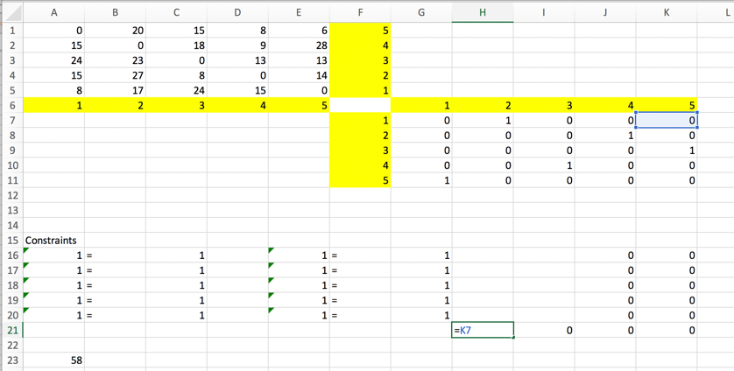

I made the cell 1, 5 = 0.

I also made sure the diagonals were all 0s in both matrices:

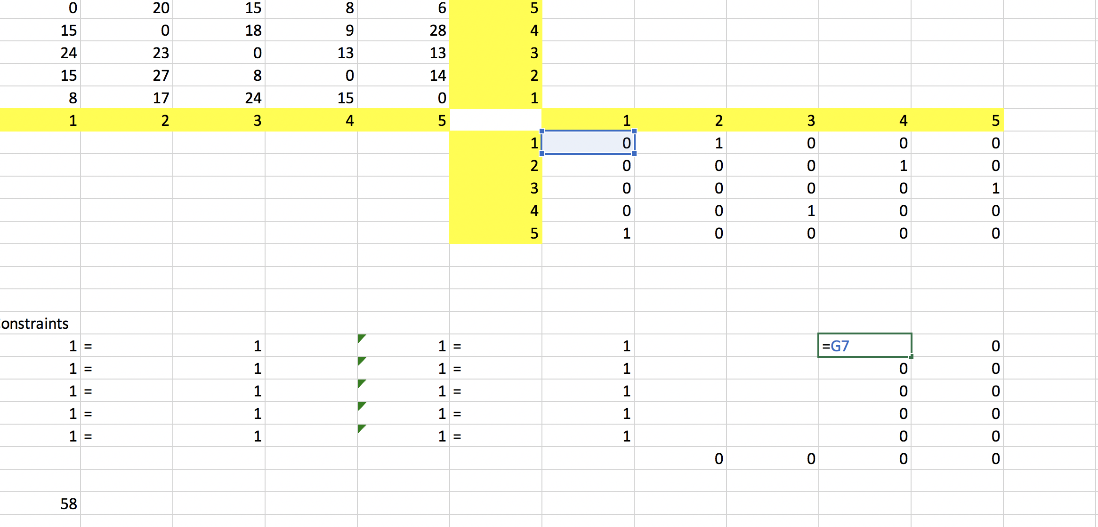

Here is the whole setup in Excel after adding the new constraints:

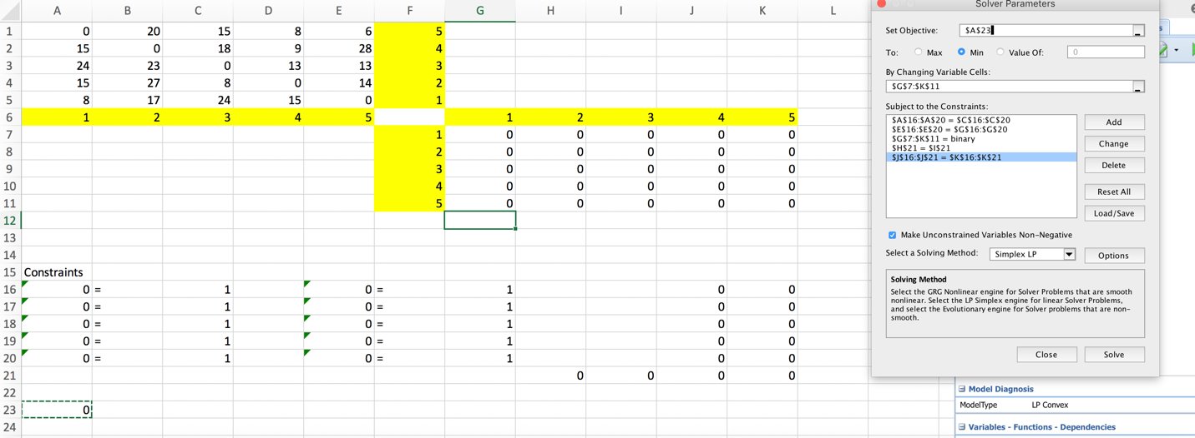

Here are the behind the cell formulas:

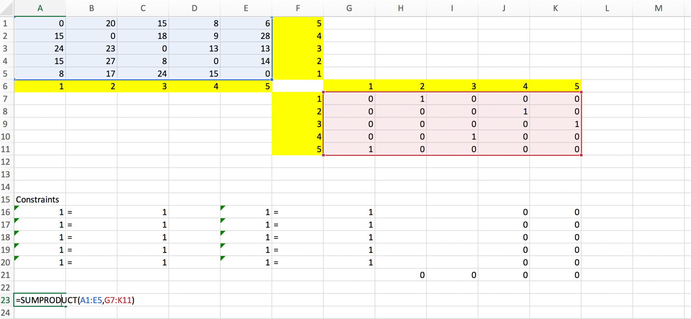

The Objective Function ^

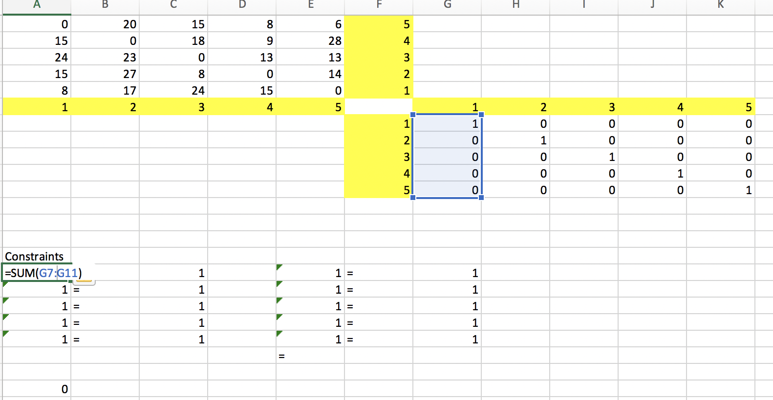

Do the same thing for each column and each row

Here is our only constraint which is a subroute between 5 and 1.

For the optimal solution we get: 58, which corresponds to the route **1, 2, 4, 3, 5, 1** and this corresponds to the times 8 + 20 + 8 + 9 + 13= 58.

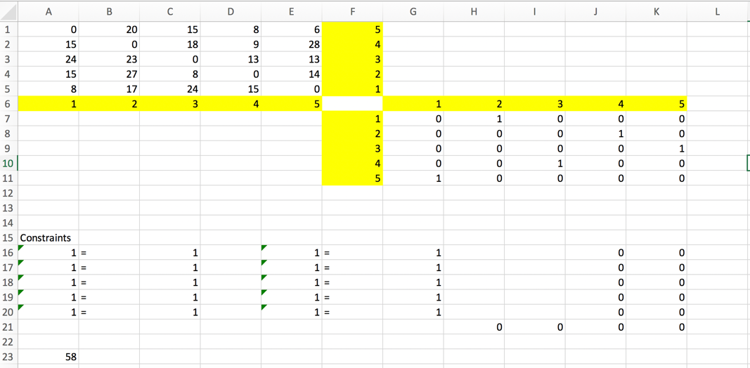

**SOLUTION FOR 10 X 10:**

Here is the setup for 10 x 10 Matrix with binary matrix. We had to add one constraint to eliminate a subroute at 5,1. After implementing those constraints, I got an optimal solution of 92.

I got a path of **1, 2, 6, 3, 5, 4, 10, 7, 8, 9, 1**. The times were 7 + 9 +6 + 7 + 15 + 5 + 6 + 16 + 14 + 7 = 92

Matrix from Problem:

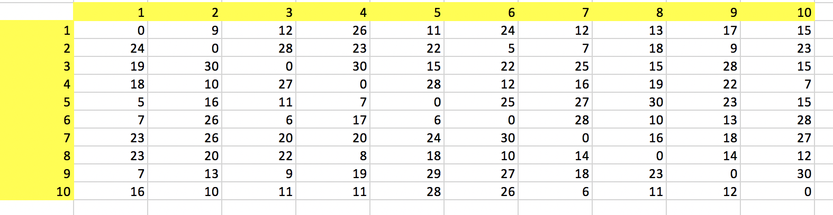

Binary Matrix:

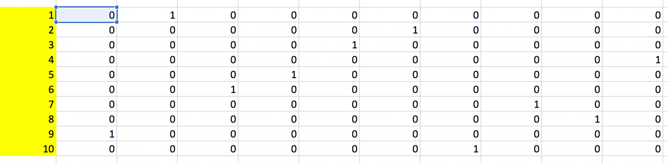

I have to add zero constraints so Binary matrix diagonals stay 0

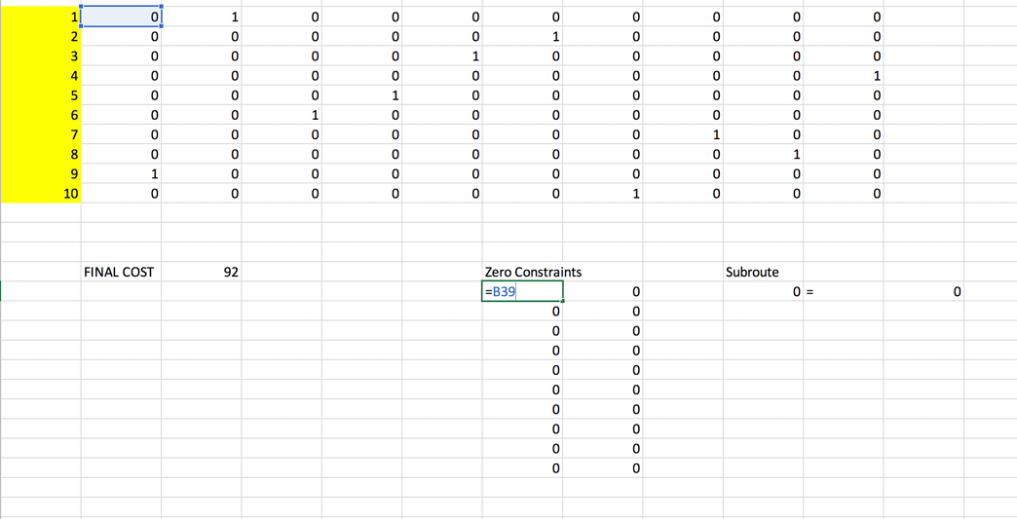

There was a subroute at 5,1 which I set = 0

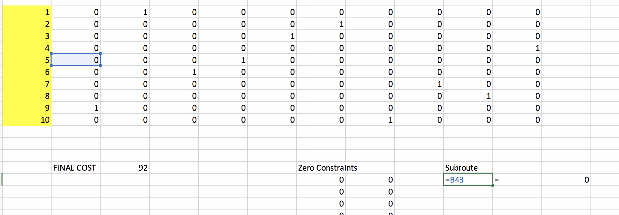

I also made constraints, so all rows and columns were = 1 defined here:

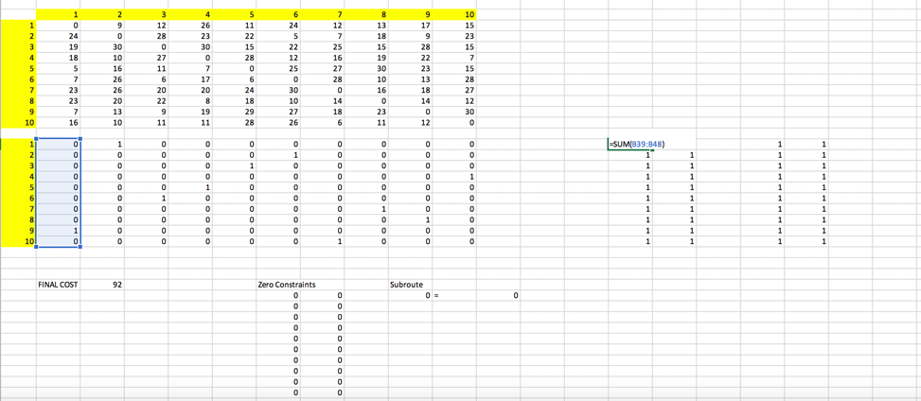

My formula below represents optimal minimization function:

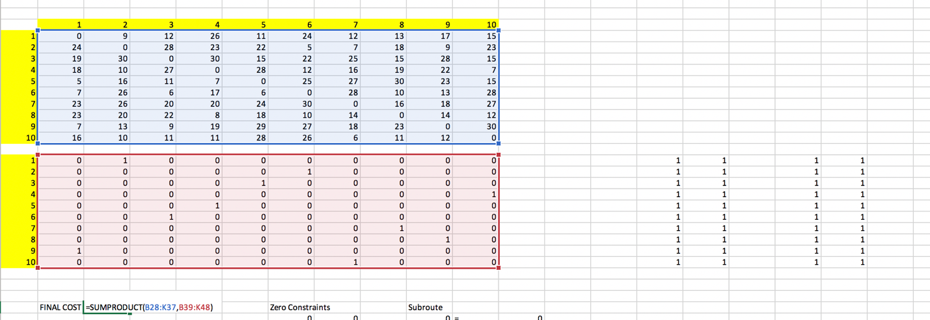

Once I found my answer I put it in solver as below:

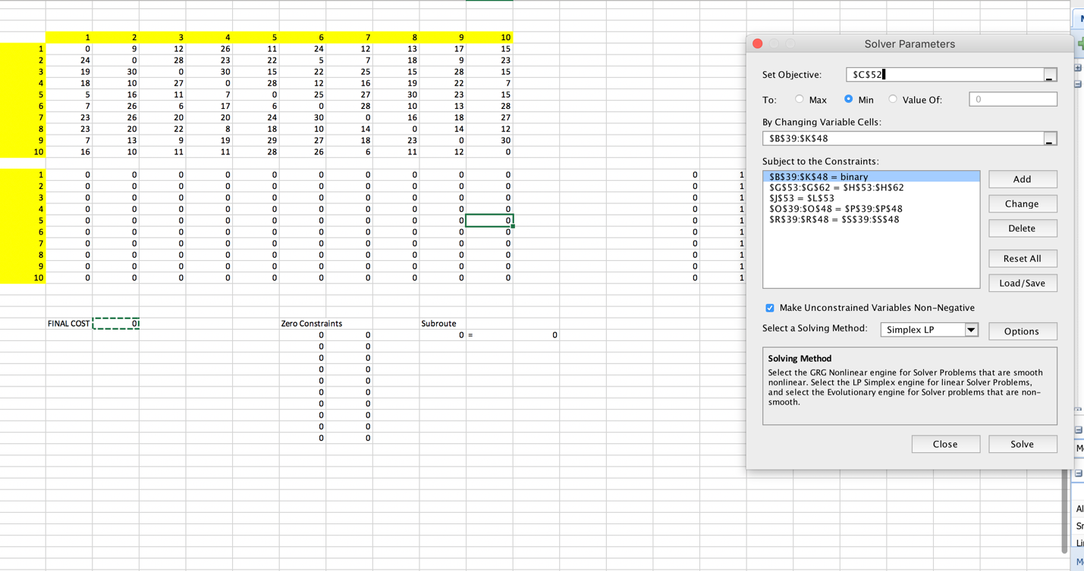

Final Output/Answer is below as well:

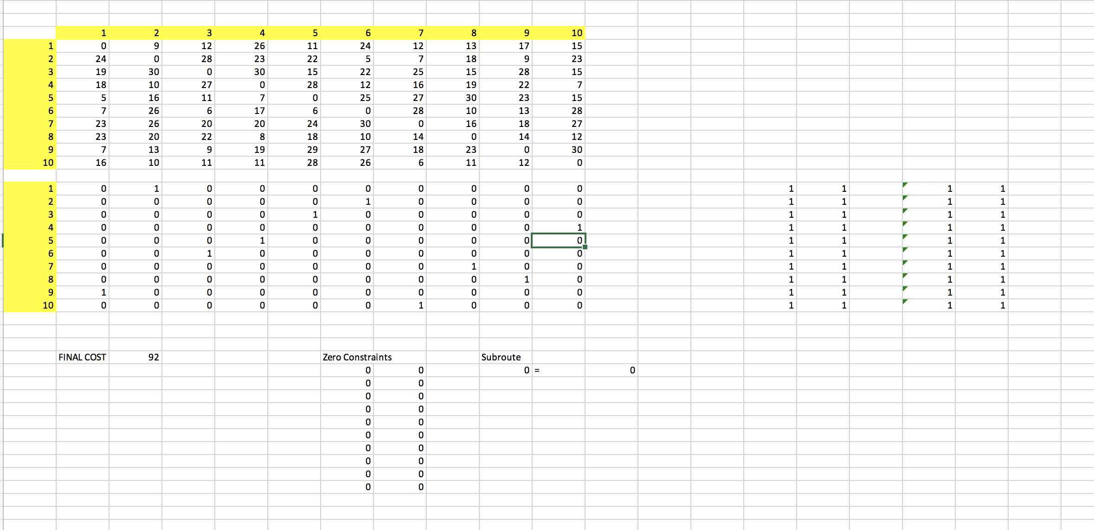

4.

MIN Priority1*(d1+) + Priority2*( 2*d2+ + d3+ + d4+) + Priority3*( d5- + d5+  + d6+ )

D1 – minimize overutilization as we do not want it to go over 40

D2 – minimize overutilization as we do not want to go over 16,000

D3 - minimize overutilization as we do not want to go over 5,000

D4 - minimize overutilization as we do not want to go over 9,000

D5 & D6 - minimize both deviational variables for budget as mentioned and minimize underutilization for d6 as we to use all the labor hours we have available.

**Priority 1**

GOAL 1: 2X1 + 2X2 + 1X3+ d1- - d1+ = 40

**Priority 2**

GOAL 2: 1.5X1 + 2X2 + 1X3+ d2- - d2+ = 16,000

GOAL 3: 0.5X1 + 0.5X2 + 1X3 + d3- - d3+ = 5,000

GOAL 4: 0.3X1 + 0.6X2 + d4- - d4+ = 9,000

**Priority 3**

GOAL 5: 7X1 +5X2 + 4X3 + d5- - d5+ = 164,000

GOAL 6: 2X1 + 2X2 + 1X3+ d6- - d6+ = 40

X1, X2, X3, d1…d6 > = 0

5.

We need to minimize the deviational variables d1…d6.

MIN Priority1*(d1-) + Priority2*(d2+) + Priority3*(d3+) + Priority4*(d4-) + Priority5*( d5- + 2*d6-)

D1 – minimize underutilization as we do not want it below 750,000

D2 – minimize overutilization as we do not want to go over 100,000

D3 - minimize overutilization as we do not want to go over 70,000

D4 - minimize underutilization as we do not want to go under 1,000,000

D5 & D6 - minimize underutilization as we do not want go under 250,000 we also know the buying power for D6 which is 25-30 age group is twice as much there for we multiply 2*d6.

**Priority 1**

GOAL 1: 10,000X1 + 7,500X2 + d1- - d1+ = 750,000 - we know that we want exposure to be at least 750,000

**Priority 2**

GOAL 2: X1 + X2 + d2- - d2+ = 100 = we have to divide 100,000/1,000 to get per 1000 dollars and scale correctly

**Priority 3**

GOAL 3: X1 + d3- - d3+ = 70 we have to divide 70,000/1,000 to get per 1000 dollars and scale correctly

**Priority 4**

GOAL 4:10,000X1 + 7,500X2 + d4- - d4+ = 1,000,000 we want at least 1,000,000 exposures

**Priority 5**

GOAL 5: 2,500X1 + 3,000X2 + d5- - d5+ = 250,000

GOAL 6: 3,000X1 + 1,500X2 + d6- - d6+ = 250,000

These two are for age groups.

X1, X2 d1…d6 > = 0

**EXTRA CREDIT**

**A.**

Patterns that the lumberyard may use to use a board of 10 feet is below.

To figure out how many patterns they will be we need to use combination formula which tells us there will be 6 patterns. 3!/(3-3)! Where r is that we have 3 options to choose from out of n elements which is also 3.

Where left over materials are less than 3 feet is:

Pattern #1 – 3 feet Boards * 3 = 9 feet used

Pattern #2 – 3 feet board *2 + 1*4 feet board = 10 feet used

Pattern #3 – 3 feet board + 5 feet board = 8 feet used

Pattern #4 – 5 feet boards * 2 = 10 feet used

Pattern #5 – 5 feet board + 4 board = 9 feet used

Pattern #6 = 4*2 = 8 feet used

B.

After figuring out our patterns we can use decision variables for each of our patterns which is equal to 6. X1…X6.

Then we can find our objective function which is to limit how many 10 feet boards we can make which is

Min X1 + X2 + X3 + X4 + X5 +X6

S.T.

We have 90 boards of 3 feet available so:

Constraint 1 is

3*X1 + 2*X2 + X3 == 90

We have 60 boards of 4 feet available so:

X2 + X5+ 2*X6 == 60

We have 60 boards of 5 feet available so:

X3 + 2*X4+ X5 == 60

MAKE SURE X1…X6 >= 0

C. Now put above in Excel:

Our formulas in Excel shown before:

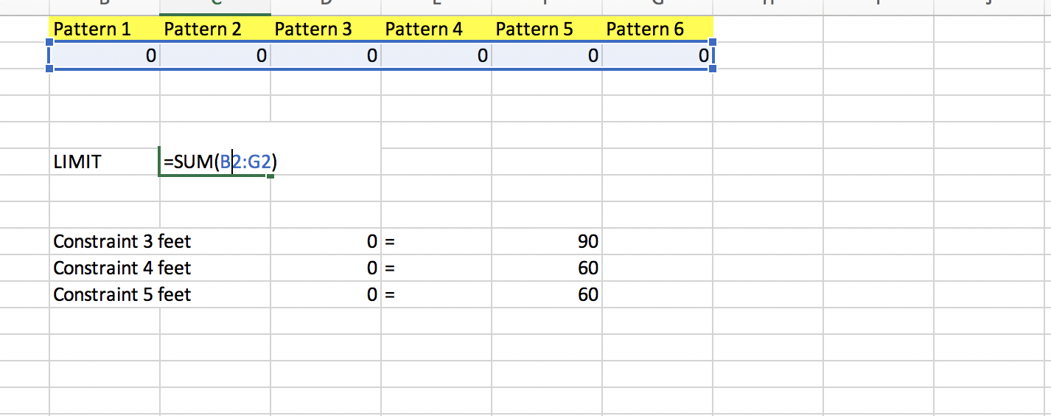

The Objective function is above.

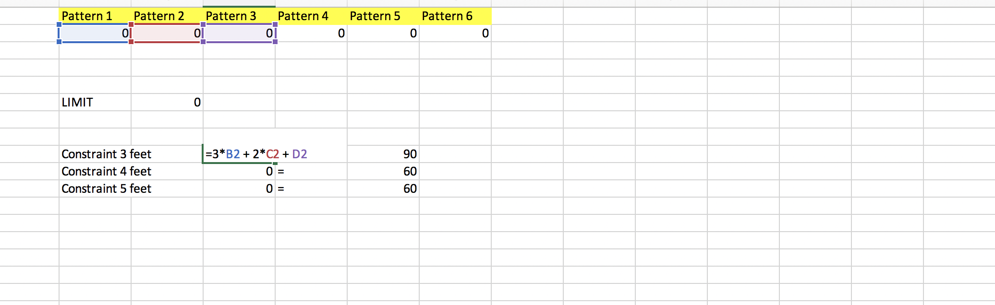

Constraint for 3 feet ^

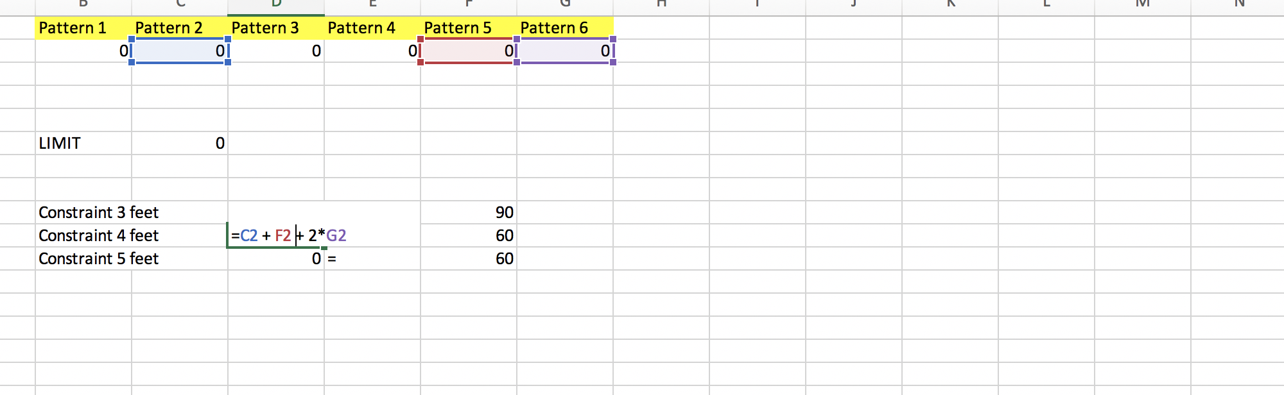

Constraint for 4 feet ^

And Constraint for 5 feet

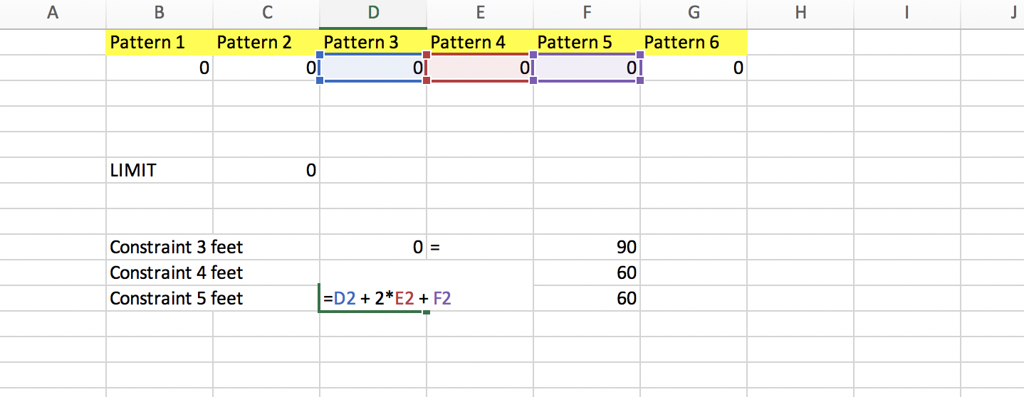

Here is our setup before solving:

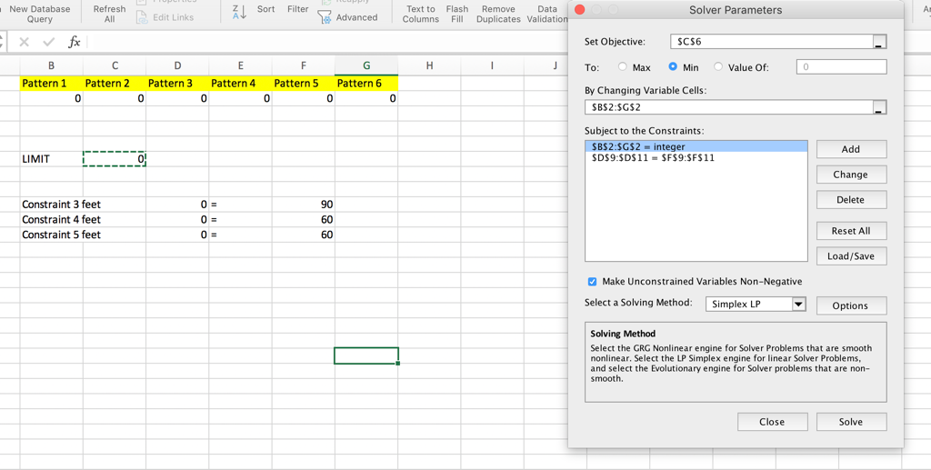

We get an optimal solution of 83 with Pattern 1 having 2 boards, Pattern 2 having 42 boards, Pattern 4 having 30 boards and Pattern 6 having 9 boards.

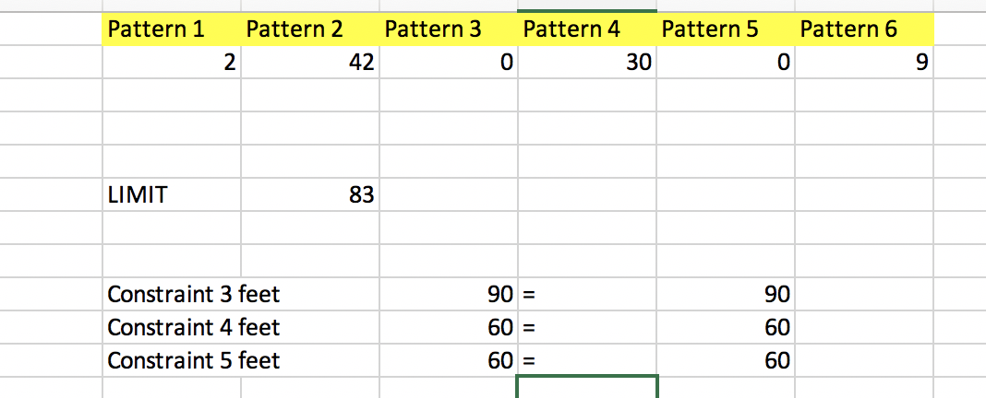

NOW WE CAN PUT SAME PROBLEM IN GUROBI PYTHON:

